What Affects Graduates In the U.S.A?

# There are many different people who attend college in the United States. People of all different races, genders, and backgrounds attend college. This begs the question “What factors affect graduation statistics?” How do things like race, gender, state, and major impact graduation rates? With our data from several thousand US schools, could there be some trend or relationship between graduation rates and these factors?

This overarching question was the driving force for our team's investigation. However, we really dug into a few things. One of the things we focused on was graduation rates by state. Another thing we looked into was if gender played any role as well. Lastly, we looked at majors to see if there were any strong correlations or findings there that affected graduation.

First, where are these schools located? The map below shows the 6000+ schools from our data.

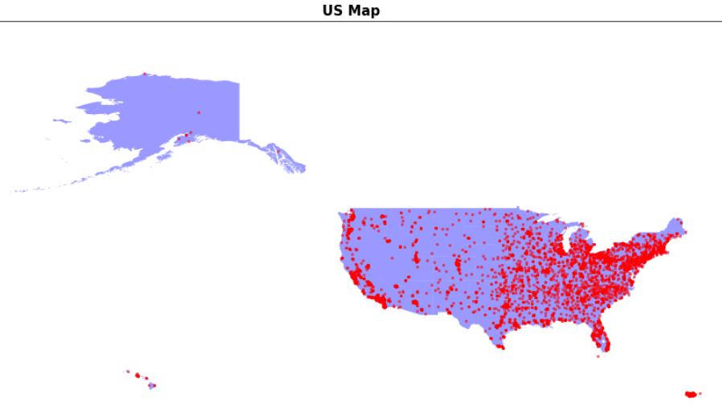

When we started this investigation on graduation rates, our team decided to find out which state you were attending college in mattered or not. We made a graph showing two things. The first was the percentage of 2020 graduates by state, and the second was the state's percentage of the US population.

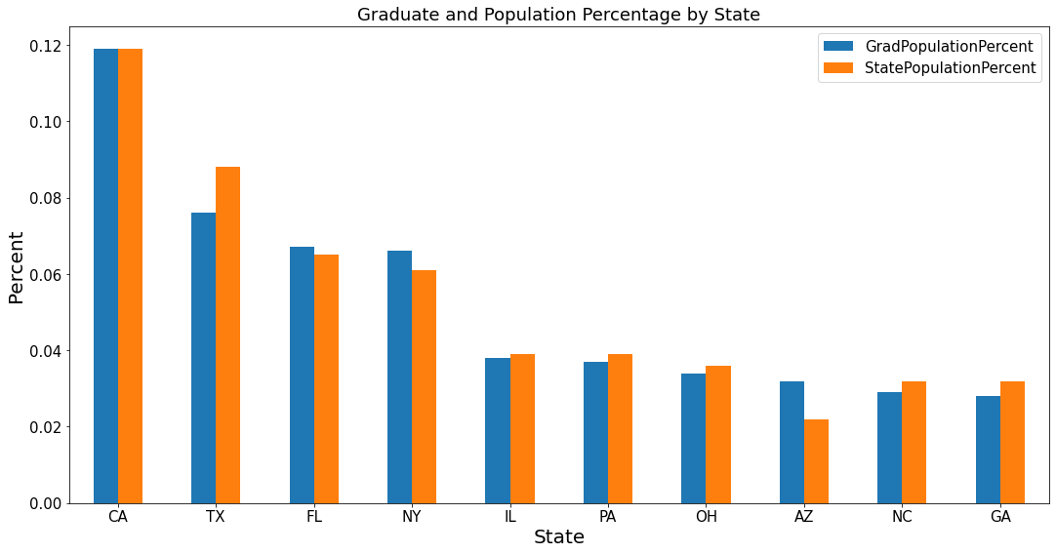

To see what this graph is really saying let's look at California (CA). The blue bar shows that California is responsible for close to 12% of all graduates. While the orange bar shows how much of the state's population makes up the total population. Notice how the two are identical so these two things are proportional for California. This trend is consistent give or take 2-3%. So this brought us to believe that it did not matter which state you attend college in because each state had the same representation across the board with its population. However, we thought that this was odd because there should be a state that does better than others in producing college graduates.

So then we came up with another question after our initial one brought interesting results. Do the most populated states have the most graduates because of their population? To answer this question we decided we would need the density of graduates per state. In order to get this number we divided the total number of graduates in that state by the total population of the state and our findings are shown in the following graph.

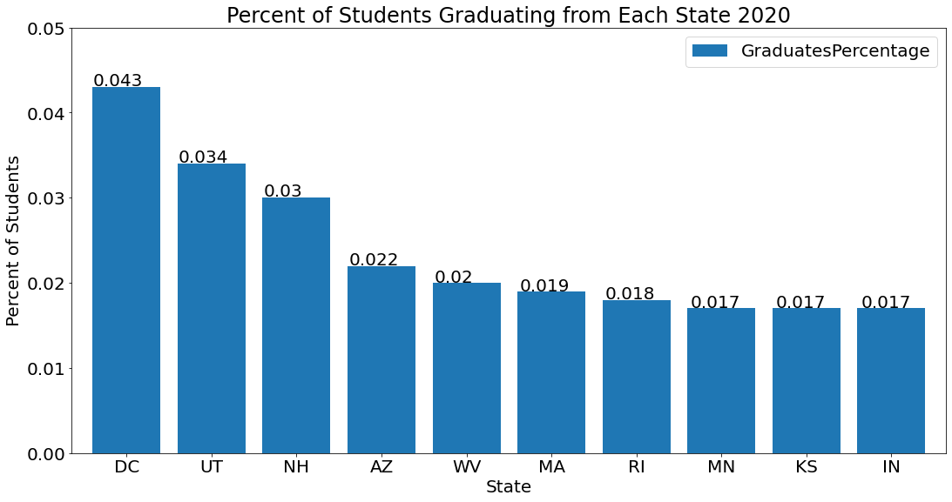

After examination of the graph, we can see that DC and Utah are the best places that produce the most graduates that represent their population in 2020. We can also see that the only state that remains in the top ten for the total number of graduates and density of graduates is Arizona.

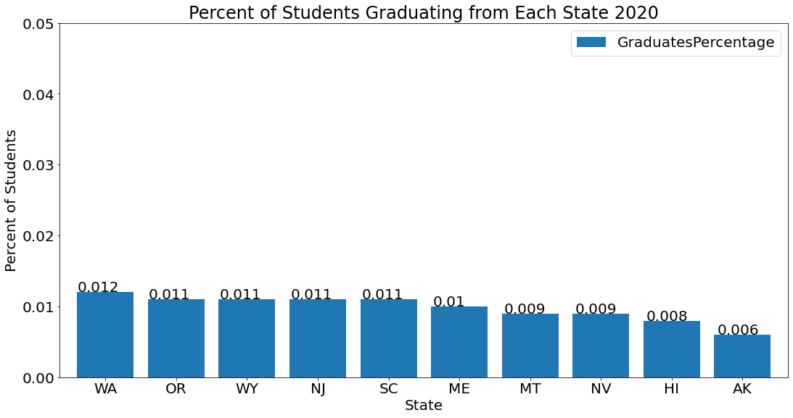

At the tail end of this graph, we can see that Hawaii and Alaska have the lowest rates of graduation by population.

We then wanted to look at how race played a role in graduation rates. We made a graph breaking down each race group (White, Black, Asian, Latino, Nonresident, Other) in each state. Below you can see the percentage of students by race for 2020 graduates.

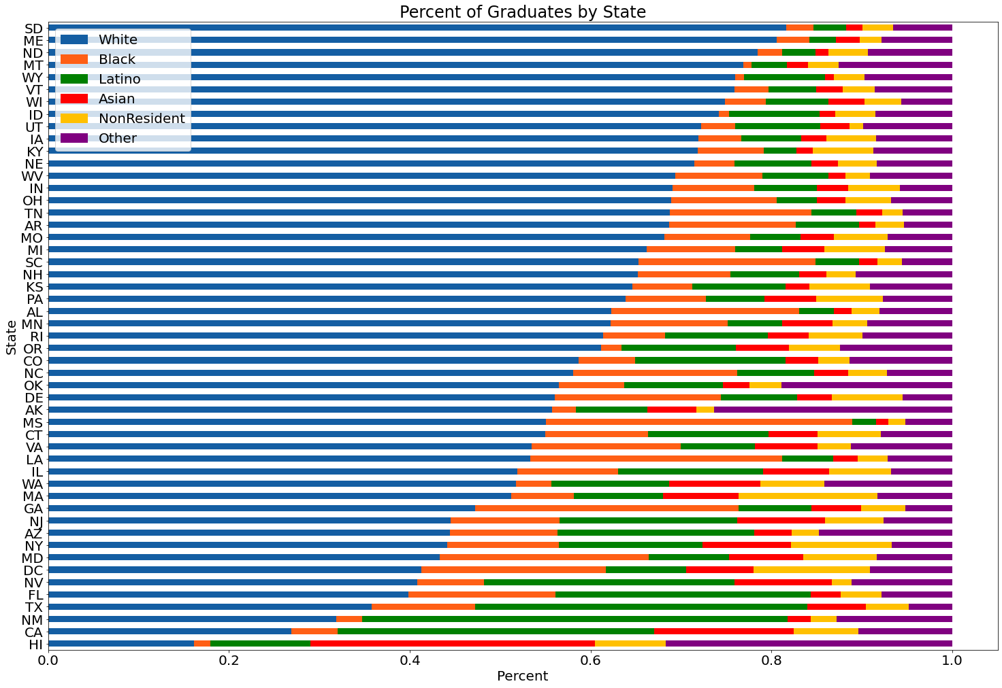

South Dakota has the highest percentage of white people, and Hawaii has the smallest. Each follows a similar, yet different trend. Southern states tend to have a higher percentage of Latinos, and California and Hawaii have higher rates of Asian people.

Once our team found the racial breakdown of each state, we then shifted our attention to whether gender played a major role in graduation. So we took the total number of graduates and divided the total number of women and men to see the breakdown of percentages. 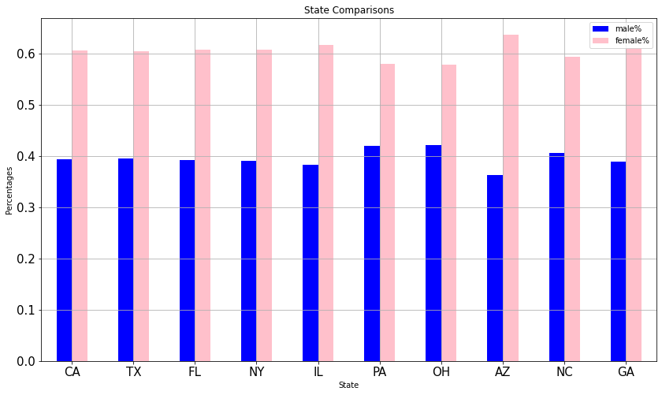

As you can see from the graph above it is once again sorted by the top populated states. Seeing the women have a higher percentage across the board was not surprising but for it to be this dominant in the top ten states was a little surprising. So then we compared all 50 states and found something even more interesting. There is no state that ever touched the 50/50 split between women and men. Women had a higher representation of graduates across all 50 states with the closest state being West Virginia with 52 percent of women making up the graduates. Women were so dominant in graduation that 48/50 states had 55 percent with 32/50 of those states having a higher percentage where women make up north of 60 percent.

The final thing we looked into was if the field of study affects the gender percentage. The results were interesting, as things were not 50/50, and men and women tend to go into different fields.

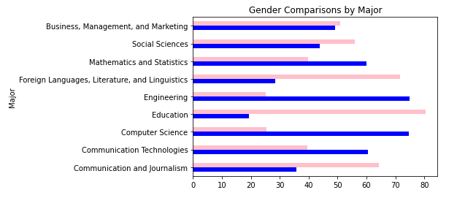

In this graph, men were more prominent in fields like Computer Science, Math, Engineering, and Technology fields. Women were more prominent in fields like Social Sciences, Languages, Education, and Journalism. The only field that we looked at that was similar was business, management, and marketing, which was almost 50/50 for gender. This makes sense since these are the most general majors that people choose.

Throughout this study, we came to the following conclusions. On average, more white people have a higher graduation rate in most states. Typically more women graduate than men. Gender does not play a role in graduation rates in different states, as women are higher than men in all states. Gender does play a role in graduation rates in different majors where Social sciences, communications, and languages are more female-dominated, and STEM majors are more male-dominated. Business is even across the board.